**Item Type Master**

* PURPOSE OF THE Item Type Master.

“Item Type Master” is used in “Supply Master”.

1. Select “Item Type Master” Menu Path :-Masters-> Pharma Retails Masters--> Disease Master.

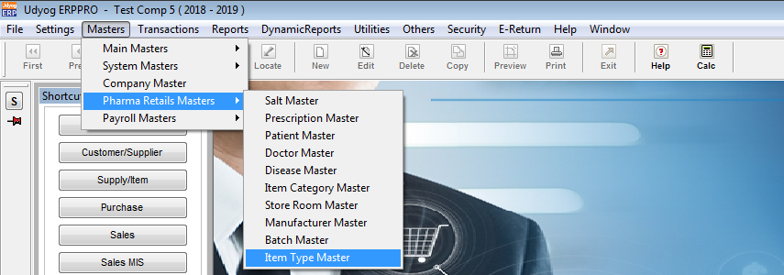

2.After Click On “Item Type Master”

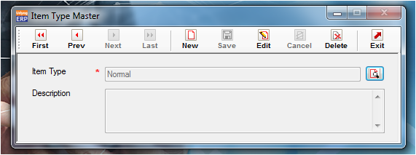

3.Below mentioned Item Type are available in default.

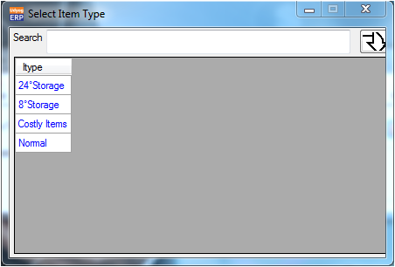

4. Validation list.

1. Duplicate Record not allowed.